**Design and Implementation of Automatic Room Light Controller, Depending on the Presence of Human**

Project Report

Electronics & Communication Engineering

Semester: 6

By

Priyadarsini Samanta (430221020105)

Aniket Chowdhury(430221010104)

Alapan Sengupta (430221010070)

Anirban Banerjee (430221010111)

Under the supervision of

Abhijit Ghosh

Department of Electronics & Communication Engineering

Narula Institute of Technology

Affiliated to Maulana Abul Kalam Azad University of Technology

West Bengal

81, Nilgunj Road, Agarpara, Kolkata-7000109

DECEMBER 2024

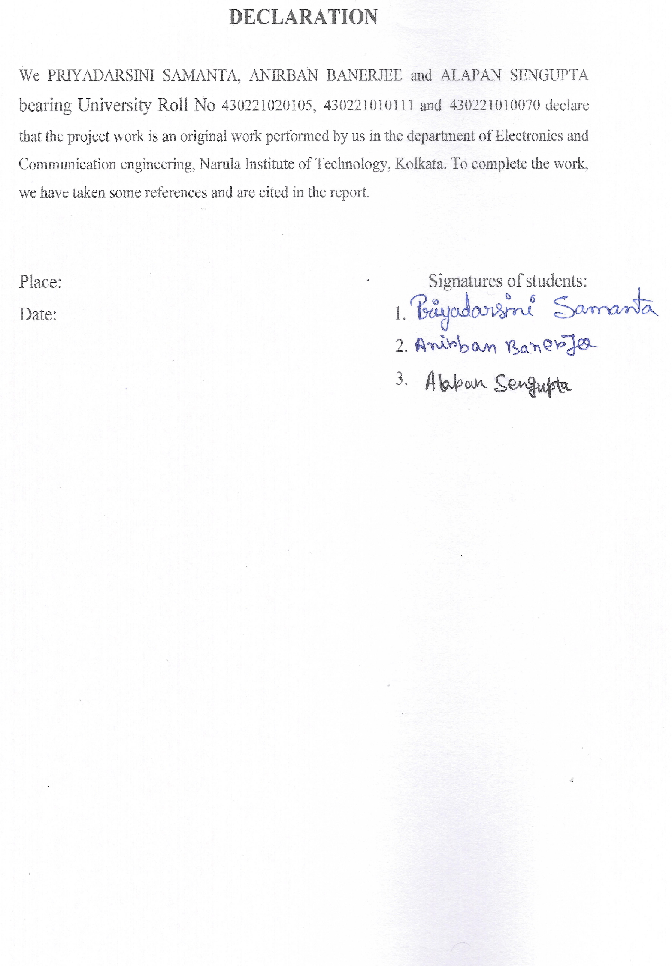

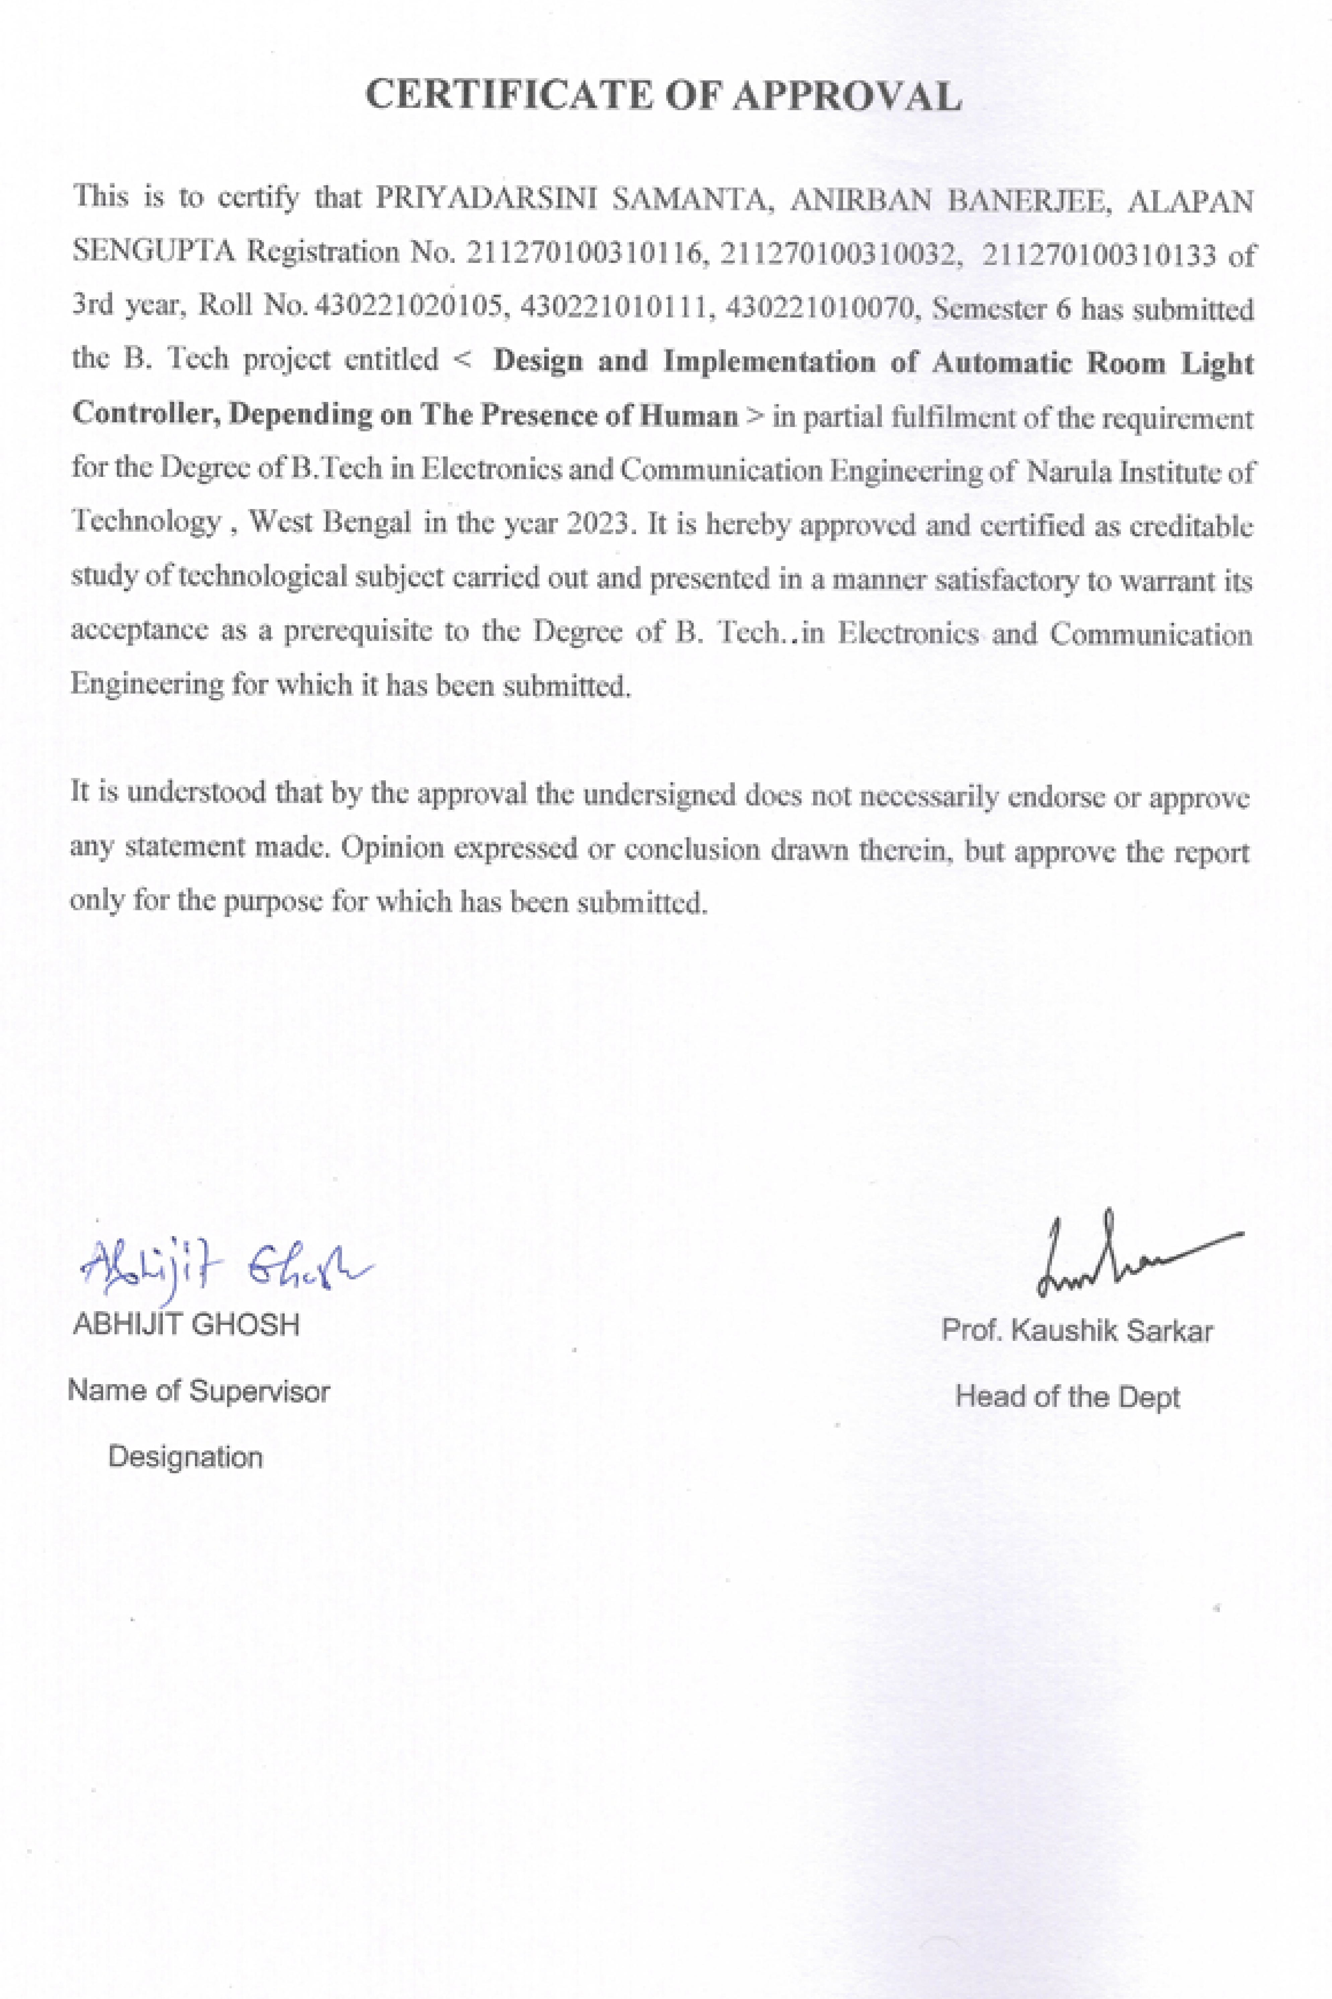

# 

**Table of Content**

|  |  |
| --- | --- |
| **CONTENT** | **PAGE NO.** |
| **Abstract** | **6** |
| **List of Components** | **6** |
| **Introduction** | **7** |
| **Specification** | **7-9** |
| **Circuit Diagram** | **10** |
| **Connection** | **11** |
| **Working** | **11-12** |
| **Code** | **12-14** |
| **Features** | **14** |
| **Result** | **14** |
| **Application** | **14** |
| **Limitation** | **14** |
| **Future Enhancement** | **15** |
| **Problem Formulation** | **15** |
| **Conclusion** | **15** |

**Abstract:** The Automatic Room Light Controller with Visitor Counter is an innovative system designed to enhance energy efficiency and security. Using sensors, it detects the presence of individuals entering and exiting a room, automatically controlling the lights accordingly. The integrated visitor counter accurately tracks the number of people in the room, ensuring lights are only on when the room is occupied. This system reduces energy wastage and provides a hands-free lighting solution. Ideal for offices, homes, and public spaces, it combines convenience with sustainability, contributing to smarter energy management and a greener environment.

LIST OF COMPONENTS

|  |  |  |  |
| --- | --- | --- | --- |
| HARDWARE | | | |
| **SL. No:** | **Components Name** | **Specification** | **Quantity** |
| 1 | Arduino UNO | ATmega328P | 1 |
| 2 | IR sensor Module | LM393 | 2 |
| 3 | LCD Display Module | 16x2 | 2 |
| 4 | Relay | 5V | 2 |
| 5 | LED | - | 2 |
| 6 | Battery | 9V | 2 |
| 7 | Bread Board | - | 1 |
| 8 | Jumper Wires | Male to Male, Male to Female | As per requirement |
| **SOFTWARE:** ARDUINO IDE | | | |

INTRODUCTION

In today's era of smart technology, energy conservation and automation are paramount. The Automatic Room Light Controller with Visitor Counter exemplifies these advancements by merging intelligent sensing technology with practical energy-saving solutions. This system is designed to automatically manage lighting in indoor environments, turning lights on and off based on real-time occupancy detection.

Utilizing infrared or ultrasonic sensors, the system monitors the entry and exit of individuals in a room. When someone enters, the lights are automatically switched on, and when everyone leaves, the lights turn off, thereby minimizing energy consumption. The integrated visitor counter not only facilitates accurate monitoring of the number of people present but also enhances the system's efficiency by ensuring that lights remain on only when the room is occupied.This technology is particularly beneficial in environments where manual control of lighting is impractical or inefficient, such as in offices, classrooms, and public facilities. By reducing unnecessary energy usage, it contributes to lower electricity bills and a reduction in carbon footprint.

In summary, the Automatic Room Light Controller with Visitor Counter is a sophisticated, eco-friendly solution that promotes smarter energy usage while offering convenience and reliability in managing indoor lighting.

**SPECIFICATION**

* **Arduino UNO:** Arduino UNO is a microcontroller board based on the **ATmega328P**. It has 14 digital input/output pins (of which 6 can be used as PWM outputs), 6 analog inputs, a 16 MHz ceramic resonator, a USB connection, a power jack, an ICSP header and a reset button. It contains everything needed to support the microcontroller; simply connect it to a computer with a USB cable or power it with a AC-to-DC adapter or battery to get started. [1]

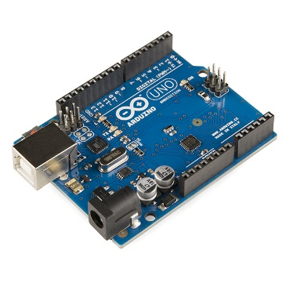

* **IR Sensor Module:** We have used 2 IR Transmitters (White LED) and 2 IR Receivers (Black LED). The reason behind choosing IR LED is, that infrared beams are not visible to human eyes and they are not easily triggered by other sources in the environment. [2]

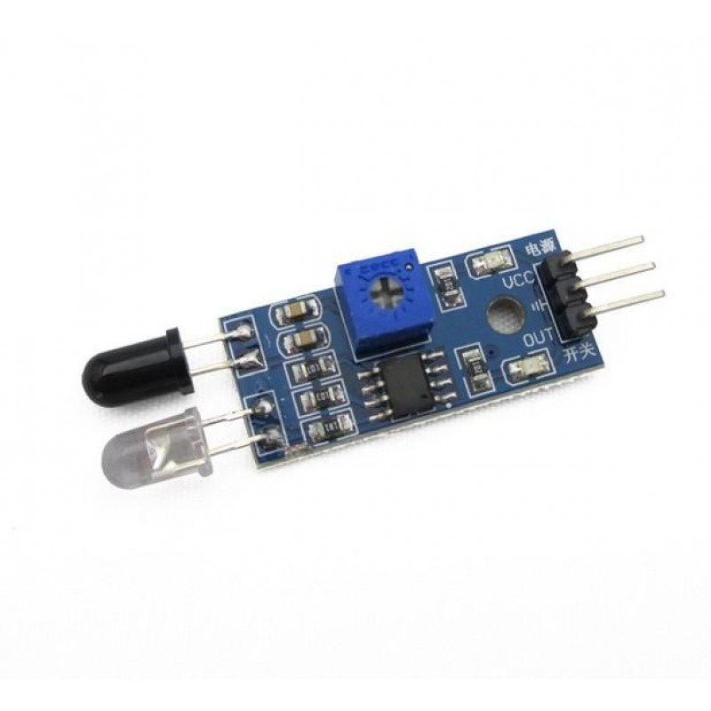

* **LCD Display Module:** We used 16X2 LCD display. The microcontroller sends the person count to LCD so that we can read the number of persons inside the room.

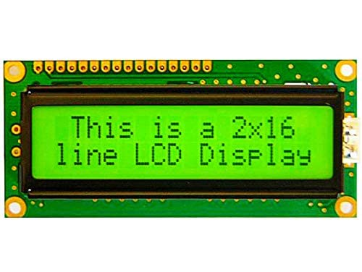

* **Relay:** A 5V relay module is a single or multi-channel relay module that works with a low-level trigger voltage of 5V DC. The input voltage can be from any microcontroller or logic chip that outputs a digital signal. Like most other relays, the 5V relay module is an electrically operated, electromagnetic switch that can be used to turn on or turn off a circuit. [3]

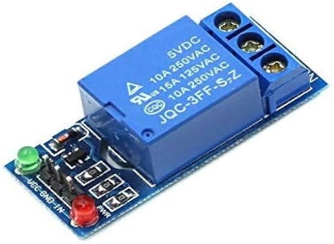

* **Battery:**  It is used to supply the power to the LEDs.

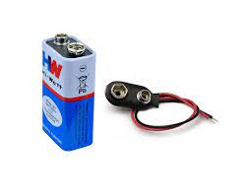

* **Bread Board:** It is a rectangular board having mounting holes present everywhere on it in a systematic manner. It is used for creating connections between components.

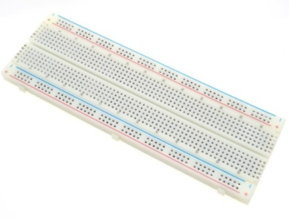

* **Jumper Wires:** It is an electrical wire having connector (pin) at each end which is used for connecting the components.

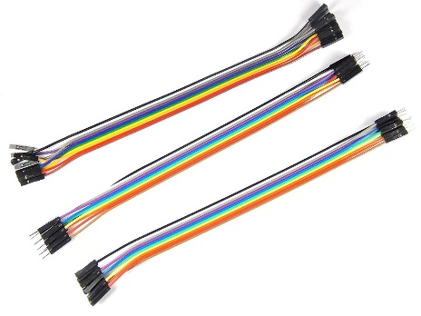

**CIRCUIT DIAGRAM**

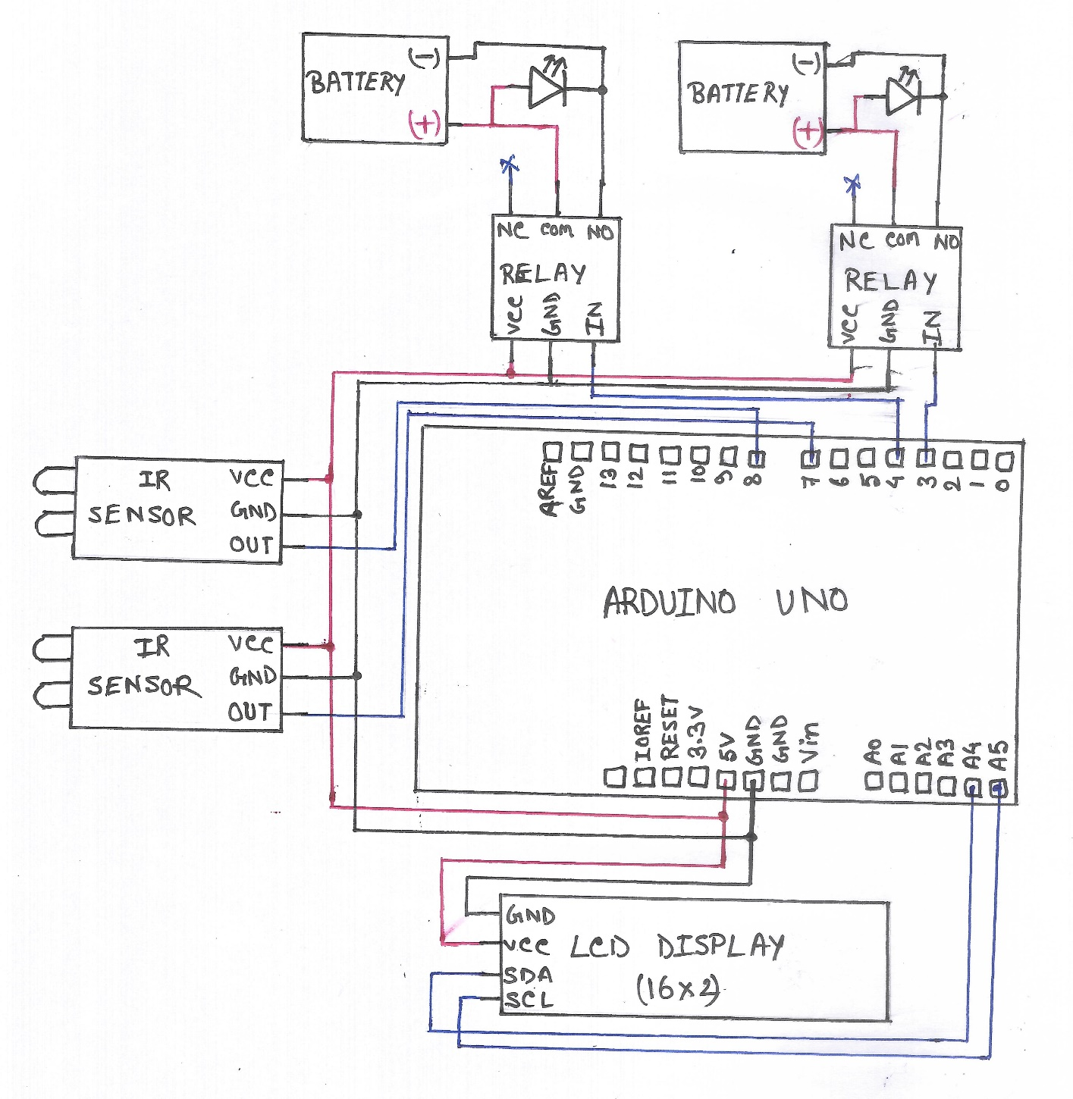

**CONNECTION**

|  |  |  |
| --- | --- | --- |
| **ARDUINO UNO** | **IR Sensor Module(2)** |  |
| 5V | VCC |  |
| GND | GND |  |
| D7, D8 | OUT |  |
| **ARDUINO UNO** | **LCD Module** |  |
| GND | GND |  |
| 5V | VCC |  |
| A4 | SDA |  |
| A5 | SCL |  |
| **ARDUINO UNO** | **Relay(2)** |  |
| GND | GND |  |
| 5V | VCC |  |
| D3, D4 | INPUT |  |
| **LED(2)** | **Relay(2)** | **Battery(2)** |
| Positive | Normally Open |  |
|  | Common | Positive |
|  | Normally Closed |  |
| Negative |  | Negative |

**WORKING**

* Room light controller:
* The IR sensor will be placed at the entry and exit gate.
* When someone will enter the room, it will count the number. As well as if someone exits the room it will also count the number of people remains in the room.
* The LCD connected with visitor counter will show the counting.
* If 3 persons enter the room only one light will turn on.
* If more than 3 persons enter the room two lights will turn on.

Now, if we want to implement another AC temperature controller, the components we need are:

* Temperature sensor (DHT22)
* IR receiver module
* Relay module

**WORKING:**

**This system will work on the basis of how many persons entering in the room because when a person entering in a room then the room temperature will increase by 0.1 to 0.5 degree Celsius per minute. So the baseline temperature will be set at 26 degree after that when persons entering the room then temperature change will be measured and automatically AC temperature will be decreased or increased.**

* AC temperature controller:
* At the beginning when occupancy is zero then it established a baseline temperature. (22 degree)
* When people start entering in the room DHT22 sensor got the data from IR sensor and calculate the temperature and decrease or increase the temperature.
* If room occupancy is high then it calculated the temperature and if temperature is high then AC temperature will decrease.
* If room occupancy is low then it calculated the temperature and if temperature is low then AC temperature will increase.

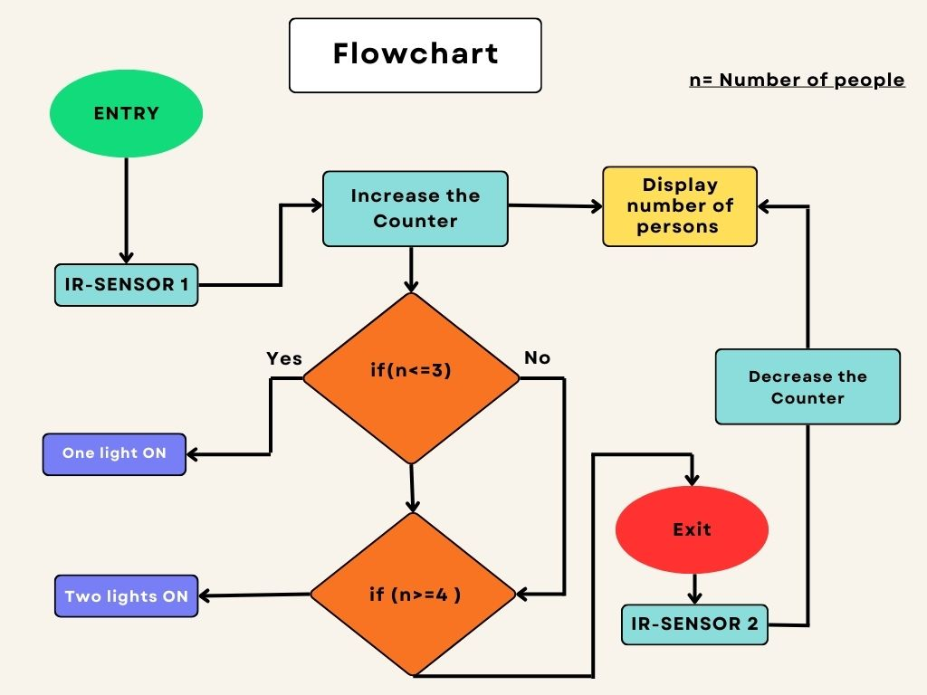

**CODE**

* For room light controller:

#include <LiquidCrystal_I2C.h>

LiquidCrystal_I2C lcd(0x27, 16,2);

#define sensorPin1 7

#define sensorPin2 8

#define relay1 3

#define relay2 4

int sensorState1 = 0;

int sensorState2 = 0;

int count=0;

void setup()

{

  pinMode (sensorPin1, INPUT_PULLUP);

  pinMode (sensorPin2, INPUT_PULLUP);

  pinMode(relay1, OUTPUT);

  pinMode(relay2, OUTPUT);

  lcd.begin(16,2);

  lcd.backlight();

  lcd.setCursor(4,0);

  lcd.print("COUNTER");

  lcd.setCursor(0,1);

  lcd.print("No Visitors");

  delay(200);

}

void loop()

{

  sensorState1 = digitalRead(sensorPin1);

  sensorState2 = digitalRead(sensorPin2);

  if(sensorState1 == LOW){

    count++;

    delay(500);

  }

  if(sensorState2 == LOW){

    count--;

    delay(500);

  }

   if(count<=0)

  {

    digitalWrite(relay1, LOW);

    digitalWrite(relay2, LOW);

    lcd.setCursor(0,1);

    lcd.print("No visitors    ");

  }

  else if (count>0 && count<4){

    digitalWrite(relay1, HIGH);

    digitalWrite(relay2, LOW);

    lcd.setCursor(0,1);

    lcd.print("Visitors:   ");

    lcd.setCursor(12,1);

    lcd.print(count);

    lcd.setCursor(13,1);

    lcd.print("  ");

  }

   else if (count>3 && count<10){

    digitalWrite(relay1, HIGH);

    digitalWrite(relay2, HIGH);

    lcd.setCursor(0,1);

    lcd.print("Visitors:   ");

    lcd.setCursor(12,1);

    lcd.print(count);

    lcd.setCursor(13,1);

    lcd.print("  ");

  }

  else {

    digitalWrite(relay1, HIGH);

    digitalWrite(relay2, HIGH);

    lcd.setCursor(0,1);

    lcd.print("Visitors:   ");

    lcd.setCursor(12,1);

    lcd.print(count);

  }

}

**FEATURES**

* It counts the number of person entering or exiting the room.
* One display available. So that one can know how many people are there in the room.
* Easy to use and setup.
* As the room light is controllable automatically, power consumption is less.

**RESULT**

* The Visitor Counter is working properly.
* Also the room light is automatically controlled as we expected.

**APPLICATION**

* It can be used in Seminar hall or Conference room.
* It can be used in home.
* It can be used in office room.

**LIMITATIONS**

* Maximum visitor counting is limited.
* If someone stays at the entrance for too long, the count will increase.
* If someone stays at the exit gate for too long, the count will decrease.

**FUTURE ENHANCEMENT**

The total system is providing a great result. So we are trying to implement an Automatic Light Controller using PIR Sensor. We are also trying to implement a smart door lock so that if there is more persons try to enter the room rather than the room capacity the door will automatically locked.

**CONCLUSION**

The Automatic Room Light Controller with Visitor Counter represents a significant leap towards more efficient and sustainable energy management. By seamlessly integrating occupancy detection with automated lighting control, this system not only optimizes energy usage but also enhances convenience and security in various settings.

The utilization of sensors to detect movement ensures that lights are only used when needed, effectively reducing unnecessary electricity consumption and contributing to lower energy costs. The visitor counter further refines this process by maintaining accurate records of room occupancy, thereby ensuring that lights remain on only when the space is occupied. This dual functionality makes the system ideal for diverse applications, ranging from residential homes to commercial offices and public buildings.

Moreover, the hands-free nature of the system increases its practicality, eliminating the need for manual light switches and thus reducing wear and tear on fixtures. It also offers an added layer of safety, particularly in environments where manual operation is not feasible or when entering dark spaces.

In conclusion, the Automatic Room Light Controller with Visitor Counter is a forward-thinking solution that aligns with modern sustainability goals. It delivers both economic and environmental benefits, making it a valuable addition to smart building technologies aimed at promoting energy efficiency and enhancing user comfort.

**REFERANCES**

1. "Board; Uno R3 SMD; Docs". Arduino. Archived from the original on May 8, 2023.
2. "https://www.electroduino.com/what-is-ir-sensor-module-how-ir-sensor-module-works/"
3. "Understanding Relays & Wiring Diagrams". Swe-Check. Retrieved 16 December 2020.